ONLINE EXAM MODULE

**Home.aspx**: Starting page of the application.

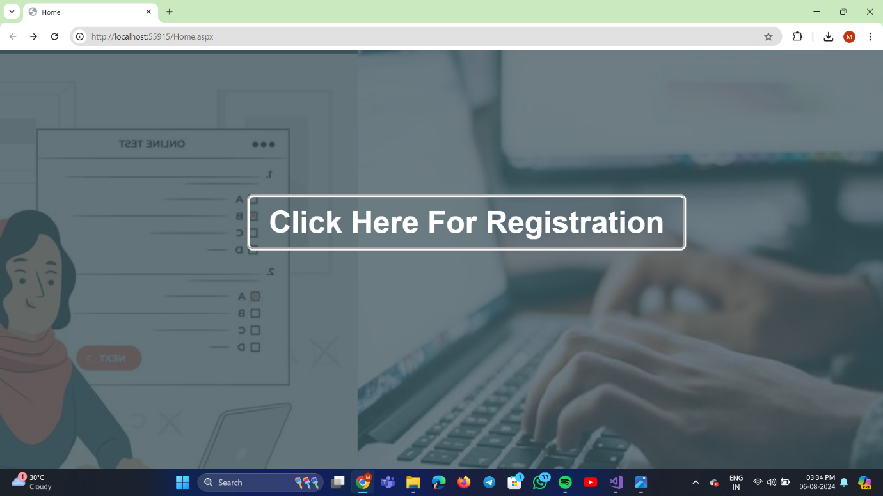

**Code:** it is directed to default.aspx i.e, registration form to register

protected void Button1_Click(object sender, EventArgs e)

{ //directed to default.aspx

Response.Redirect("Default.aspx");

}

**Default.aspx**: Registration form will open and it will directed to login page when click on the login button.

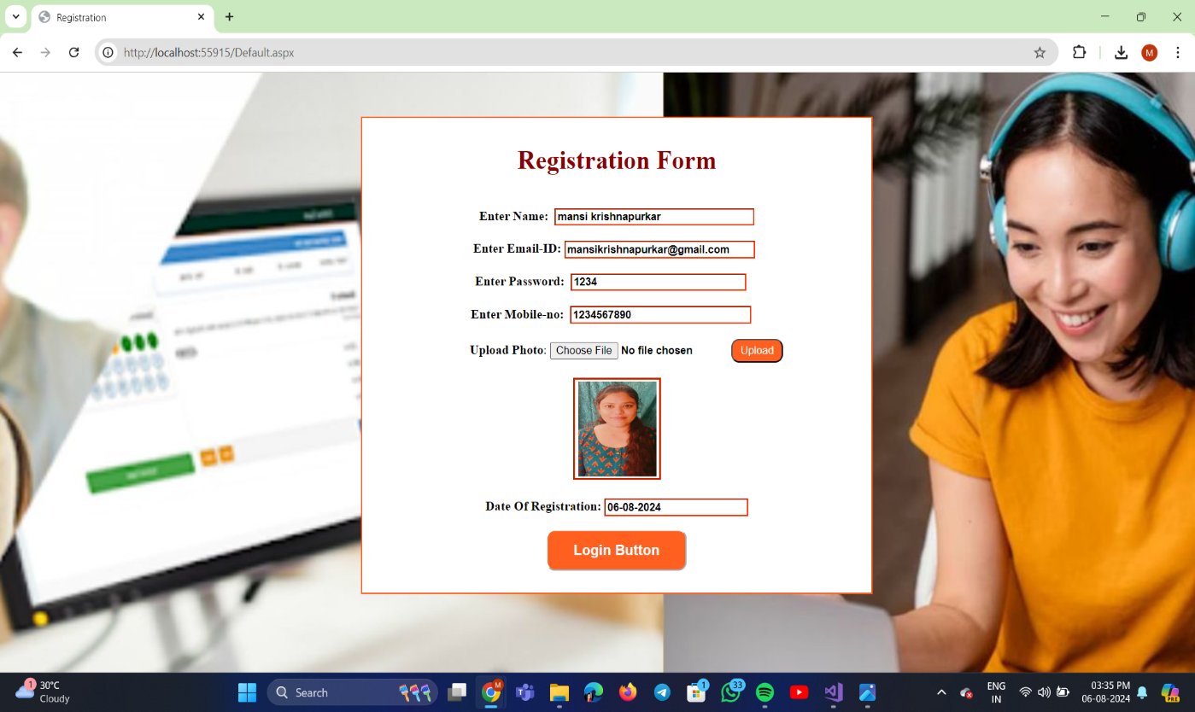

It also has validation on email-id and mobile-no.

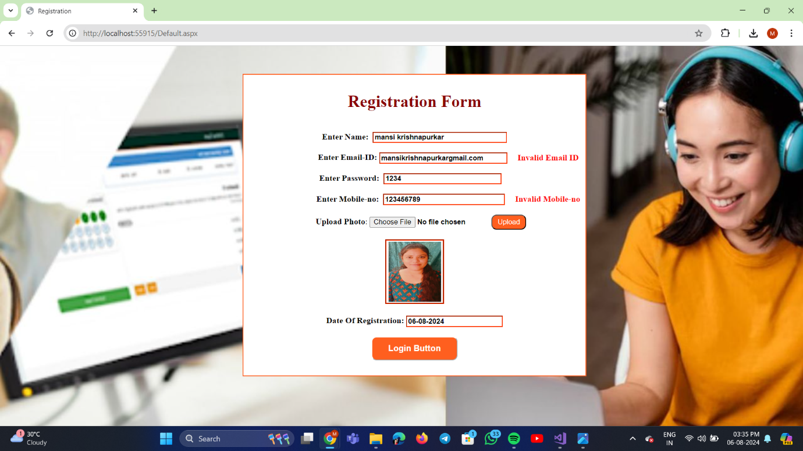

**Code:**

using System;

using System.Collections.Generic;

using System.Linq;

using System.Web;

using System.Web.UI;

using System.Web.UI.WebControls;

namespace OnlineExamModule

{

public partial class Default : System.Web.UI.Page

{

protected void Page_Load(object sender, EventArgs e)

{

//to display current date for registration

TextBox5.Text = DateTime.Now.ToString("dd/MM/yyyy");

}

protected void TextBox5_TextChanged(object sender, EventArgs e)

{

}

protected void Button2_Click(object sender, EventArgs e)

{

//to upload the image or say photo

FileUpload1.SaveAs(Server.MapPath("~")+"//photoUpload//"+ FileUpload1.FileName);

//to see image preview inside image control

Image1.ImageUrl = "~/photoUpload/" + FileUpload1.FileName;

}

protected void Button1_Click(object sender, EventArgs e)

{

//to redirect from Default.aspx to Login.aspx

//Response.Redirect("Login.aspx"); --> no need to give because when we are transffering data using querystring at that time we are also redirecting to login.aspx page

//query string for transfering data to match Email-ID and Password

//for email and password

Response.Redirect("Login.aspx?email=" + TextBox2.Text + "&password=" + TextBox3.Text + "&name=" + TextBox1.Text + "&image=" + Image1.ImageUrl);

}

}

}

**Login.aspx:** Here it will check whether the email-id and password correct or not if incorrect then will not directed to next page i.e., Exam.aspx after clicking the button create exam button.

When email-id and password incorrect:

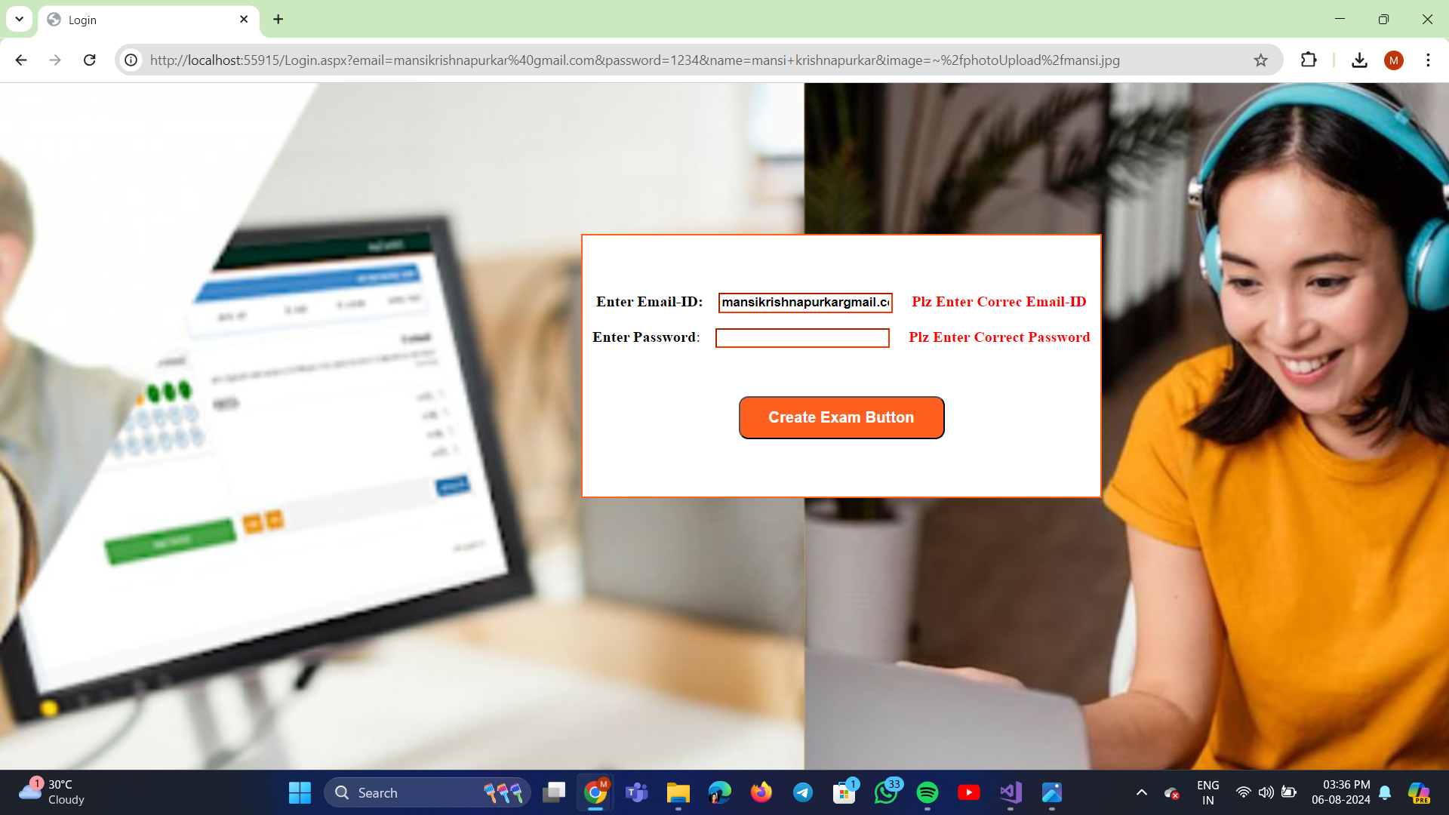

When email-id and password is correct:

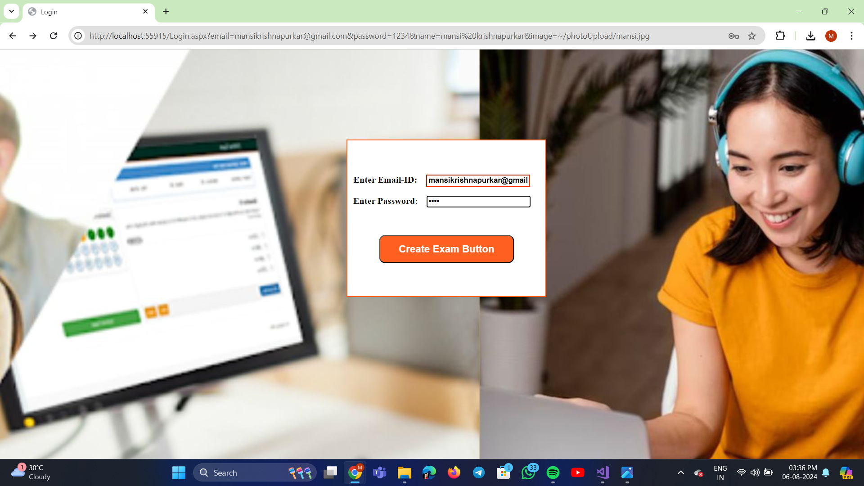

**Code:**

using System;

using System.Collections.Generic;

using System.Linq;

using System.Web;

using System.Web.UI;

using System.Web.UI.WebControls;

namespace OnlineExamModule

{

public partial class Login : System.Web.UI.Page

{

protected void Page_Load(object sender, EventArgs e)

{

}

protected void Button1_Click(object sender, EventArgs e)

{

//Access data to check correct email-id and password using QueryString

//if both email-id and password are correct

if((TextBox1.Text == Request.QueryString["email"]) && (TextBox2.Text == Request.QueryString["password"]))

{

Response.Redirect("Exam.aspx?email=" + TextBox1.Text + "&name=" + Request.QueryString["name"] + "&image=" + Request.QueryString["image"]);

}

//if email is incorrect

if(TextBox1.Text != Request.QueryString["email"])

{

Label1.Text = "Plz Enter Correc Email-ID";

}

else

{

Label1.Text = "";

}

//if password is incorrect

if(TextBox2.Text != Request.QueryString["password"])

{

Label2.Text = "Plz Enter Correct Password";

}

else

{

Label2.Text = "";

}

}

}

}

**Exam.aspx:** Here name and email automatically display and user have to enter other details and click on test start button it will directed to Testscreen.aspx page.

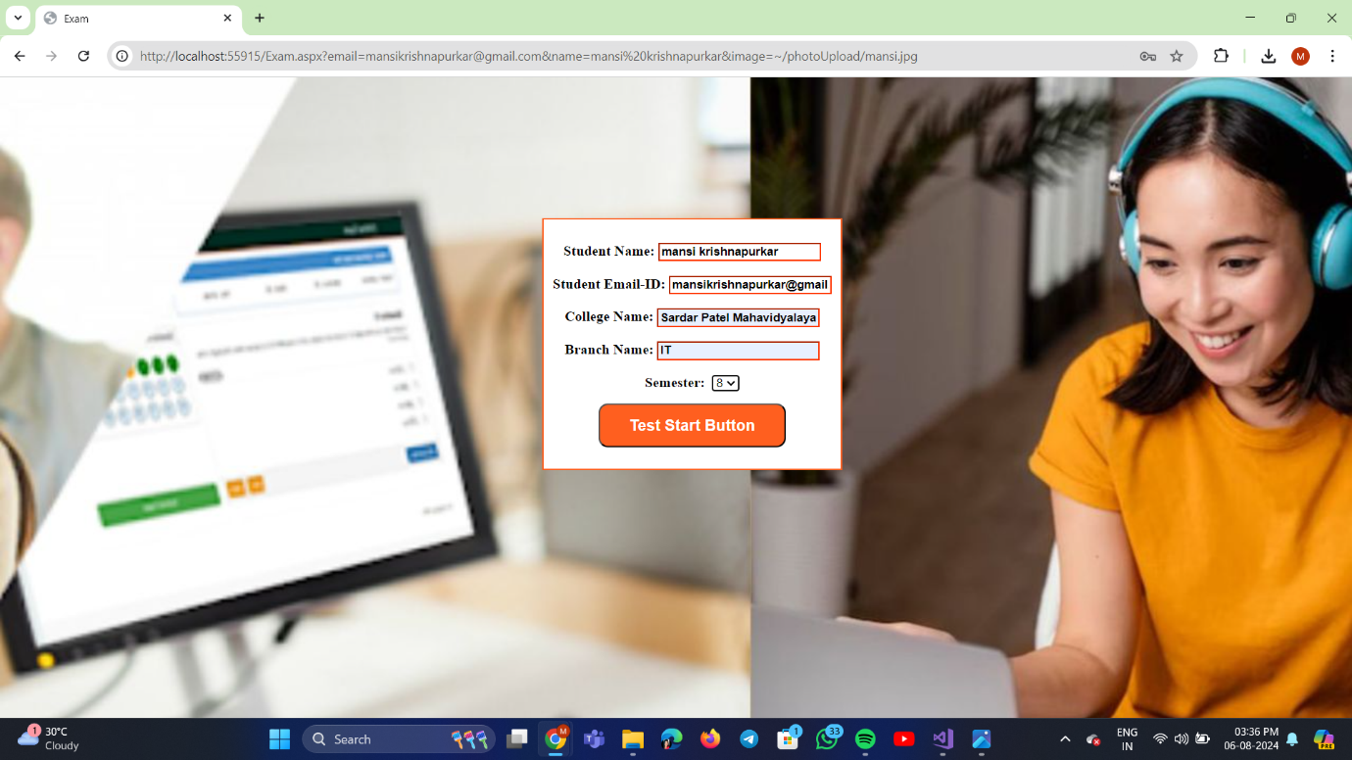

**Code:**

using System;

using System.Collections.Generic;

using System.Linq;

using System.Web;

using System.Web.UI;

using System.Web.UI.WebControls;

namespace OnlineExamModule

{

public partial class Exam : System.Web.UI.Page

{

protected void Page_Load(object sender, EventArgs e)

{

//to automatically display student name and email-id

TextBox1.Text = Request.QueryString["name"];

TextBox2.Text = Request.QueryString["email"];

}

protected void Button1_Click(object sender, EventArgs e)

{

//directed to Testscreen.aspx page

Response.Redirect("Testscreen.aspx?collegename=" + TextBox3.Text + "&name=" + TextBox1.Text + "&email=" + TextBox2.Text + "&branch=" + TextBox4.Text + "&semester=" + DropDownList1.Text + "&image=" + Request.QueryString["image"]);

}

}

}

**Textscreen.aspx:** here in this page the exam page will appear with total 10 exam on clicking on each button the question will appear and after completing the test click on submit score button it will open the score card.

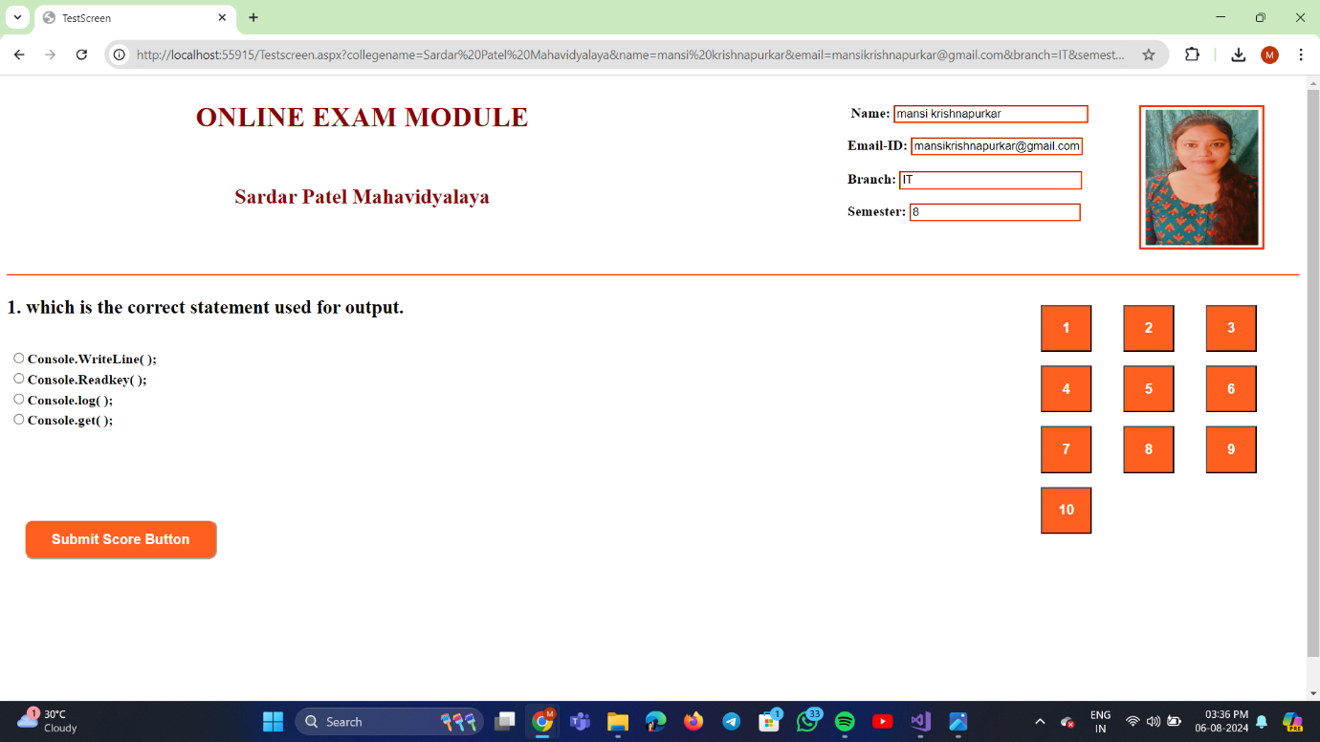

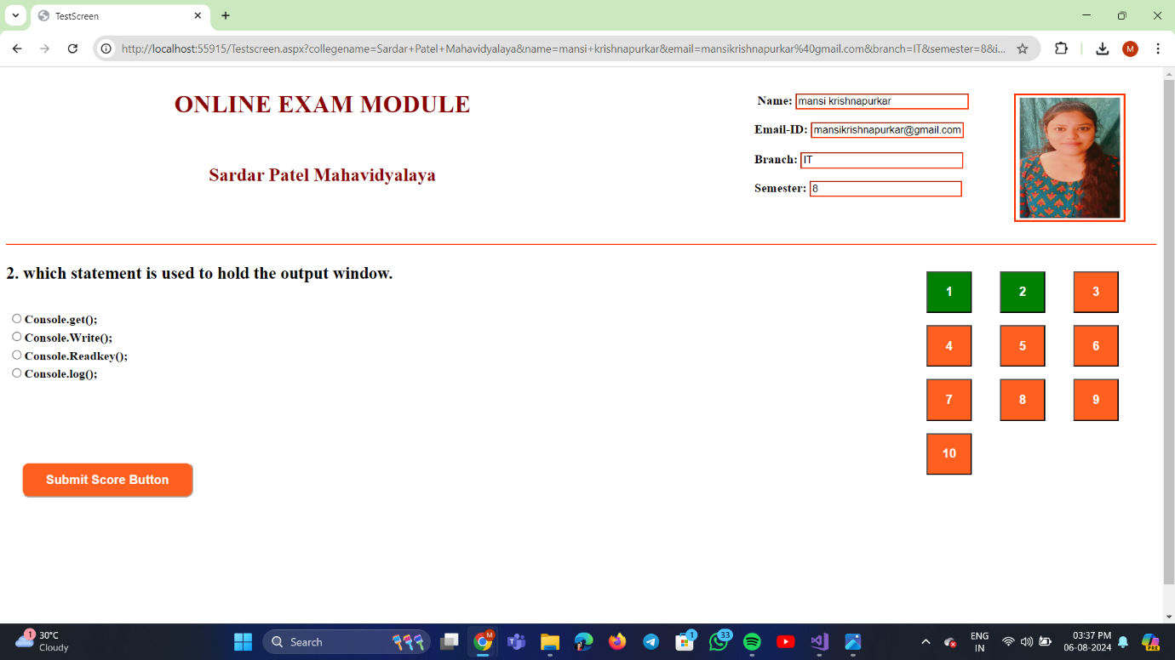

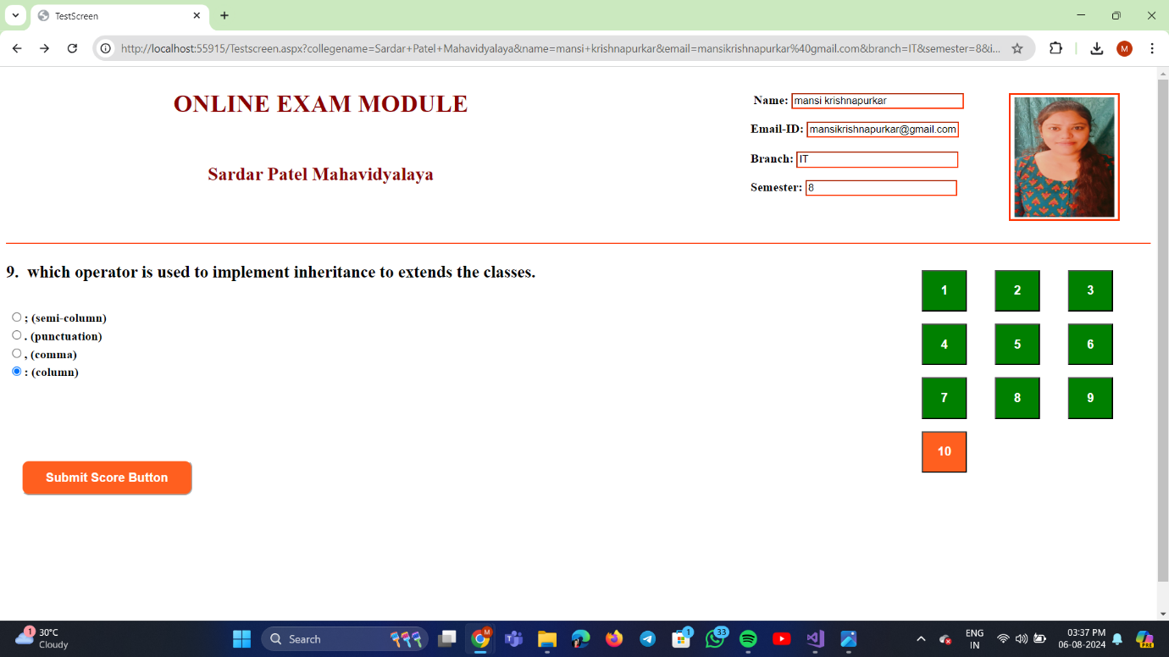

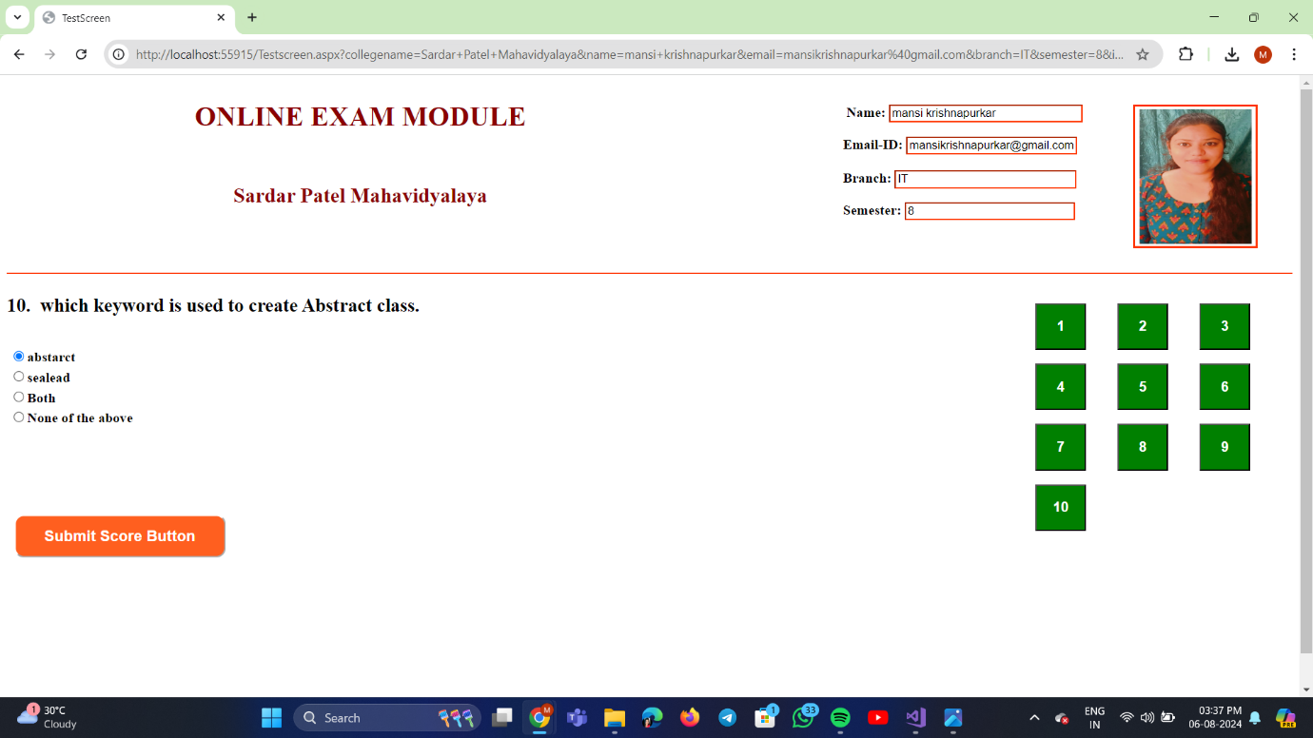

**Code:**

using System;

using System.Collections.Generic;

using System.Linq;

using System.Web;

using System.Web.UI;

using System.Web.UI.WebControls;

namespace OnlineExamModule

{

public partial class Testscreen : System.Web.UI.Page

{

protected void Page_Load(object sender, EventArgs e)

{

//to display automatically information

Label1.Text = Request.QueryString["collegename"];

TextBox1.Text = Request.QueryString["name"];

TextBox2.Text = Request.QueryString["email"];

TextBox3.Text = Request.QueryString["branch"];

TextBox4.Text = Request.QueryString["semester"];

Image1.ImageUrl = Request.QueryString["image"];

}

protected void Button2_Click(object sender, EventArgs e)

{

//to open que1

MultiView1.ActiveViewIndex = 0;

//to change color of button into green when clicked

Button2.BackColor = System.Drawing.Color.Green;

}

protected void Button3_Click(object sender, EventArgs e)

{

//to open que2

MultiView1.ActiveViewIndex = 1;

//to change color of button into green when clicked

Button3.BackColor = System.Drawing.Color.Green;

}

protected void Button4_Click(object sender, EventArgs e)

{

//to open que3

MultiView1.ActiveViewIndex = 2;

//to change color of button into green when clicked

Button4.BackColor = System.Drawing.Color.Green;

}

protected void Button5_Click(object sender, EventArgs e)

{

//to open que4

MultiView1.ActiveViewIndex = 3;

//to change color of button into green when clicked

Button5.BackColor = System.Drawing.Color.Green;

}

protected void Button6_Click(object sender, EventArgs e)

{

//to open que5

MultiView1.ActiveViewIndex = 4;

//to change color of button into green when clicked

Button6.BackColor = System.Drawing.Color.Green;

}

protected void Button7_Click(object sender, EventArgs e)

{

//to open que6

MultiView1.ActiveViewIndex = 5;

//to change color of button into green when clicked

Button7.BackColor = System.Drawing.Color.Green;

}

protected void Button8_Click(object sender, EventArgs e)

{

//to open que7

MultiView1.ActiveViewIndex = 6;

//to change color of button into green when clicked

Button8.BackColor = System.Drawing.Color.Green;

}

protected void Button9_Click(object sender, EventArgs e)

{

//to open que8

MultiView1.ActiveViewIndex = 7;

//to change color of button into green when clicked

Button9.BackColor = System.Drawing.Color.Green;

}

protected void Button10_Click(object sender, EventArgs e)

{

//to open que9

MultiView1.ActiveViewIndex = 8;

//to change color of button into green when clicked

Button10.BackColor = System.Drawing.Color.Green;

}

protected void Button11_Click(object sender, EventArgs e)

{

//to open que10

MultiView1.ActiveViewIndex = 9;

//to change color of button into green when clicked

Button11.BackColor = System.Drawing.Color.Green;

}

protected void RadioButtonList1_SelectedIndexChanged(object sender, EventArgs e)

{

//to generate score

if(RadioButtonList1.SelectedIndex == 0)

{

Label2.Text = "1";

}

else

{

Label2.Text = "0";

}

}

protected void RadioButtonList2_SelectedIndexChanged(object sender, EventArgs e)

{

if(RadioButtonList2.SelectedIndex == 2)

{

Label3.Text = "1";

}

else

{

Label3.Text = "0";

}

}

protected void RadioButtonList3_SelectedIndexChanged(object sender, EventArgs e)

{

if (RadioButtonList3.SelectedIndex == 1)

{

Label4.Text = "1";

}

else

{

Label4.Text = "0";

}

}

protected void RadioButtonList4_SelectedIndexChanged(object sender, EventArgs e)

{

if (RadioButtonList4.SelectedIndex == 0)

{

Label5.Text = "1";

}

else

{

Label5.Text = "0";

}

}

protected void RadioButtonList5_SelectedIndexChanged(object sender, EventArgs e)

{

if (RadioButtonList5.SelectedIndex == 3)

{

Label6.Text = "1";

}

else

{

Label6.Text = "0";

}

}

protected void RadioButtonList6_SelectedIndexChanged(object sender, EventArgs e)

{

if (RadioButtonList6.SelectedIndex == 2)

{

Label7.Text = "1";

}

else

{

Label7.Text = "0";

}

}

protected void RadioButtonList7_SelectedIndexChanged(object sender, EventArgs e)

{

if (RadioButtonList7.SelectedIndex == 0)

{

Label8.Text = "1";

}

else

{

Label8.Text = "0";

}

}

protected void RadioButtonList8_SelectedIndexChanged(object sender, EventArgs e)

{

if (RadioButtonList8.SelectedIndex == 3)

{

Label9.Text = "1";

}

else

{

Label9.Text = "0";

}

}

protected void RadioButtonList9_SelectedIndexChanged(object sender, EventArgs e)

{

if (RadioButtonList9.SelectedIndex == 3)

{

Label10.Text = "1";

}

else

{

Label10.Text = "0";

}

}

protected void RadioButtonList10_SelectedIndexChanged(object sender, EventArgs e)

{

if (RadioButtonList10.SelectedIndex == 0)

{

Label11.Text = "1";

}

else

{

Label11.Text = "0";

}

}

protected void Button1_Click(object sender, EventArgs e)

{

//to calculate score

Label12.Text = (int.Parse(Label2.Text) + int.Parse(Label3.Text) + int.Parse(Label4.Text) + int.Parse(Label5.Text) + int.Parse(Label6.Text) + int.Parse(Label7.Text) + int.Parse(Label8.Text) + int.Parse(Label9.Text) + int.Parse(Label10.Text) + int.Parse(Label11.Text)).ToString();

//data transferring to format.aspx using QueryString

Response.Redirect("format.aspx?total=" + Label12.Text + "&name=" + TextBox1.Text + "&branch=" + TextBox3.Text);

}

}

}

**Format.aspx:** here user will get the score card of the exam.

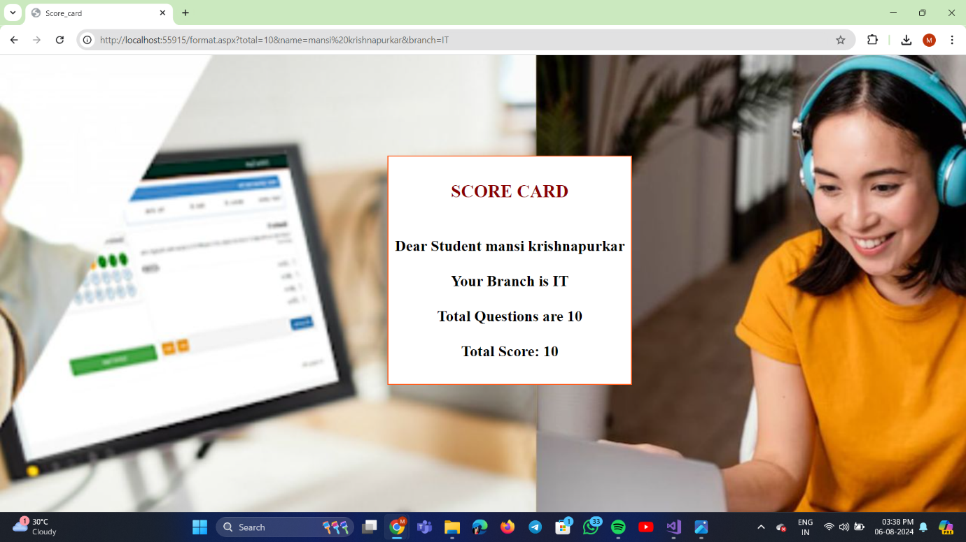

**Code:**

using System;

using System.Collections.Generic;

using System.Linq;

using System.Web;

using System.Web.UI;

using System.Web.UI.WebControls;

namespace OnlineExamModule

{

public partial class format : System.Web.UI.Page

{

protected void Page_Load(object sender, EventArgs e)

{

//to show data accessing data using QueryString

Label1.Text = "Dear Student " + Request.QueryString["name"];

Label2.Text = "Your Branch is " + Request.QueryString["branch"];

Label3.Text = "Total Questions are 10";

Label4.Text = "Total Score: " + Request.QueryString["total"];

}

}

}